**Transformation through *Da'wah Bil Hal*: Martial Art Nahdlatul Ulama’ Pagar Nusa Utilizes Vacant Land in Lembor**

**Moh. Azmi Lafif**

[*azmimuhammad382@gmail.com*](mailto:azmimuhammad382@gmail.com)

Sunan Ampel State Islamic University Surabaya, Indonesia

**Abdul Halim**

[*halim2014999@gmail.com*](mailto:halim2014999@gmail.com)

Sunan Ampel State Islamic University Surabaya, Indonesia

**Avita Aniqotul ‘Athiyyah**

Maulana Malik Ibrahim State Islamic University Malang, Indonesia

[avitaaniqotul@gmail.com](mailto:avitaaniqotul@gmail.com)

**Abstract**. *This research discusses the process of da'wah transformation which focuses on the process of transforming da'wah bil hal and the implementation of transformative da'wah bil hal Pencak Silat Nahdlatul Ulama' Pagar Nusa through the use of vacant land in Lembor Village, Brondong District, Lamongan Regency. This research uses the ABCD (Asset Based Community Development). The result of the da'wah transformation process carried out is that the community, especially Pagar Nusa members, is able to change the da'wah process which was initially only focused and considered them only in the context of martial arts into an organization that is able to preach in the context of the social environment. In addition, Pagar Nusa Lembor was able to start the economic independence of the organization, which previously the organization had never had income from an economic perspective to be an income from the results of the use of the vacant land. Then there was a change in terms of knowledge from Pagar Nusa members about how to use vacant land. As well as the da'wah from the members of Pagar Nusa in conveying the importance of protecting the environment in Islam.*

**Keywords*:*** *Da'wah Bil Hal, Pagar Nusa, Transformation Process*

**Abstrak**. *Penelitian ini membahas tentang proses transformasi dakwah yang berfokus pada proses transformasi dakwah bil hal dan implementasi dakwah bil hal transformatif Pencak Silat Nahdlatul Ulama’ Pagar Nusa melalui pemanfaatan lahan kosong di Desa Lembor Kecamatan Brondong kabupaten Lamongan. Penelitian ini menggunakan metode pendekatan ABCD (Asset Based Community Development). Hasil dari proses transformasi dakwah yang dilakukan adalah masyarakat utamanya anggota Pagar Nusa mampu merubah proses dakwah yang awalnya hanya fokus pada bela diri menjadi organisasi yang mampu berdakwah dalam konteks sosial lingkungan. Selain itu**, mampu memulai adanya kemandirian ekonomi organisasi, yang sebelumnya tidak pernah memiliki pemasukan dari segi ekonomi menjadi adanya pemasukan dari hasil pemanfaatan lahan kosong tersebut. Kemudian adanya perubahan pengetahuan dari anggota Pagar Nusa tentang cara pemanfaatan lahan kosong. Serta adanya dakwah dari anggota Pagar Nusa dalam penyampaian pentingnya menjaga lingkungan dalam agama islam.*

**Kata kunci:** *Dakwah Bil Hal,* Pagar Nusa, Proses Transformasi

**Introduction**

*Da'wah bil hal* is one of the interesting study themes. This is because *da'wah bil hal* is one of the accesses in the process of transforming the use of vacant land and illustrates how *da'wah bil hal* can bring positive changes in society. *Da'wah bil hal*, as discussed in this study, focuses on pencak silat Nahdlatul Ulama' Pagar Nusa which uses vacant land as a process of da'wah transformation can be more easily accepted and positively affect the community [1]. This shows the effectiveness of the implementation of *da'wah bil hal*, one of which is about the process of transforming the use of vacant land *(Ihyaul Mawat).*

Ihyaul mawat (cultivating unproductive land into productive) is a concept in Islam that refers to efforts to revive or restore what has been dead or forgotten in religious life. The term "ihyaul mawat" in the context of religion refers to efforts to revive the spirit and religious practices that have faded or been neglected by individuals or communities [2]. In the book Fathul Qorib Mujib, Imam Al-Rafi'i said in Syarah As-Shoghir, the meaning of al-mawat is [3].

)ارض التي لامالك لهاولاينتفع بها احد(

*It means "land that has no owner and is not used by anyone".*

In the book Fathul Qorib Mujib, it is also stated that the law of ihyaul mawat is permissible with two conditions, namely it is managed by Muslims, and the second is that the land that is revived does not have status or is not land owned by someone else [4].

Da'wah transformation is a change and renewal in methods, approaches, and strategies for delivering Islamic teachings to the community. Because the development of the times requires adaptive alignment to meet the needs of the community as well as the challenges faced by Muslims. The transformation of da'wah refers to a shift in the focus and orientation of da'wah from simply pursuing a religious agenda to a more comprehensive and holistic scope, covering economic, social, health, political, cultural, technological, and other aspects. This transformation process can be realized through various ways, such as oral da'wah bil (orally), da'wah bil qalam (da'wah in writing), and da'wah bil ḥal (da'wah with action) [5].

The transformation of da'wah in this study is da'wah bil hal in Pencak Silat Nahdlatul Ulama (PSNU) Pagar Nusa, Lembor Village, which has a focus on da'wah activities in art and martial arts into an organization that can also preach in terms of environmental and social use. To realize the process of da'wah transformation, it is said in the book Fathul Qorib Mujib: [6].

**(**وَإِنْ أَرَادَ الْمُحْيِي احْيَاءَ الْمَوَاتِ بُسْتَانًا فَجَمْعُ التَّرَابِ وَالتَّخويْطُ حَوْلَ أَرْضِ الْبُسْتَانِ إِنْ جَرَتْ بِهِ عَادَةً وَيُشترط مع ذلك الْعَرْشِ عَلَى الْمَذْهَبِ)

*It means: "If the person who cultivates the mawat land wants to make a garden, he must collect soil and make a fence around the garden land if it has been done. In addition, it is also required to plant something according to the opinion of al madzhab".*

In this case, ihya mawat is a process of transformation of da'wah bil hal, which involves the use of vacant land for good and productive purposes, such as sustainable agriculture, and preserving the environment. Through this approach, it is necessary to have an ihya mawat movement in the context of da'wah bil hal about combining Islamic religious values in concrete actions to make there is productivity on vacant land that must be carried out by Pencak Silat Nahdlatul Ulama Pagar Nusa [7].

The vacant land used in this study has an area of 16x34 M or about 554 M2 and is located in Lembor Village. The Lembor Village area as a whole has an area of agricultural land of around 427.6 Ha. This land is a land that is included in the Mamlukkah category. Because the status of this land is owned by the Branch Leader of Nahdlatul Ulama Lembor Village. However, the responsibility for the management and use of the land has been given and entrusted to Pencak Silat Nahdlatul Ulama' Pagar Nusa Lembor Village as the NU Autonomous Body. The purpose of this grant is so that the land can be managed properly and used effectively to support the organization's activities [8].

There are several previous studies whose research is relevant to this research. Including; first, by Joko Reskiyono, who discussed the purpose and function of Pagar Nusa as a medium of Islamic da'wah in the style of Nahdlatul Ulama' to the surrounding community [9]. Second, by Syaiful Hidayat, who discussed the use of vacant land and making processed derivatives from TOGA plants such as herbal medicine, various dishes and drinks [10]. Third, by Bambang Iswahyudi, who discussed the da'wah of pencak silat Pagar Nusa which has an opening greeting of 12 movements, conveying the message of da'wah to Pagar Nusa students so that it is practiced so that it is beneficial to the community [11]. The similarity with the previous research lies in the object of study used, which both discuss Pagar Nusa and Da'wah Bil Hal. Meanwhile, the difference lies in the method used. This study uses the ABCD (Asset Bassed Community Development) method which focuses on Pagar Nusa in Lembor Village in the process of transforming the use of vacant land.

Da'wah Bil Hal is a da'wah method that focuses on real actions and examples. In this approach, da'wah is not only carried out through direct teaching but also through attitudes, behaviors, and morals that can be emulated by others [12]. This concept aims to improve physical and spiritual well-being and happiness by advancing initiatives, participation, and community self-help. In addition to da'i, kyai, or ustadz, the general public is also involved in creating social, economic, and cultural frameworks according to Islamic teachings. This approach emphasizes character formation and self-development as a means of da'wah [13].

Ihyaul Mawat in Fiqh refers to the process of reviving dead or unused soil. This term comes from the word "ihya" which means to live and "mawat" which means death. Imam Al-Rafi'i defines al-mawat as land that has no owner and is not utilized [14]. In practice, the law of Ihyaul Mawat is permissible if the land is managed by Muslims and not owned by others. This concept emphasizes the use of unproductive resources for the benefit of the community, in accordance with the terms and conditions applicable in Fiqh [15].

Transformation is a radical change from the old form to the new form, which cannot return to the original form. This process occurs gradually and is not always predictable, depending on various influencing factors [16]. Transformation involves three main stages: Investment, Diffusion, and Consequence. Invention is a change that starts from within society, Diffusion is a shift towards new improvement or innovation, and Consequence is the impact of the change. This process influences the culture and conditions of the community, resulting in a thorough and sustained change in their social structure [17].

The purpose of this research is da'wah bil that the things that Pencak Silat Pagar Nusa does can have a transformative impact on the members of Pagar Nusa in terms of thinking, awareness and creativity, can inspire others to participate in efforts to revive unproductive land, protect the environment, and contribute positively to society. both for the people of Lembor Village and the general public at large. In addition, so that Pencak Silat Nahdlatul Ulama' Pagar Nusa Desa Lembor can provide insight with transformation efforts that show the practical relevance of religious teachings in social and community contexts.

**Methods**

This research method uses the Asset-Based Community Development (ABCD) method, which focuses on identifying and utilizing existing assets in the community to develop sustainable solutions that are relevant to the local context [18]. The ABCD approach differs from traditional methods that often start by identifying problems or shortcomings in the community. Instead, ABCD emphasizes the potential and strength possessed by the community. The main stages carried out in this study using the ABCD method include: Inculturation, Discovery, Dream, Design, and Destiny *[19].*

The data collection techniques used in this study are; 1) Observation and documentation, in order to see the subject and object directly. 2) Interviews, in order to collect data directly from the interviewees. 3) Focus group discussion, in order to unite various views, ideas, and beliefs, and produce mutual understanding. The data validation techniques used are; Triangulation of techniques, triangulation of sources, and triangulation of team composition. Meanwhile, the data analysis techniques used were the Low Hanging Fruit Technique and the Most Significant Change Technique.

**Results and Discussions**

The da'wah process carried out by researchers and Pencak silat Nahdlatul Ulama Pagar Nusa in carrying out the transformation process using the Asset Based Community Development (ABCD) approach is a structured work plan or guidebook about activities that can be carried out. The following are the dynamics of the field process experienced by the researcher with Pencak Silat NU Pagar Nusa Lembor Village:

1. **Inculturation**

Inculturation is a process of self-introduction and approach to the community, which in this study is the initial phase in field research. So, the inculturation carried out by the researcher to Pagar Nusa Lembor, the goal is to be able to know and know the indigenous culture of the local community and the researcher also comes as part of the community. This stage is intended so that the members of Pencak Silat NU Pagar Nusa understand the researcher's objectives, so that the researcher gains the trust of the members. Inculturation is carried out in several ways, starting from gathering with Pagar Nusa members through casual chat activities, discussions, community service, meetings, participating in pencak exercises, tahlilan and various other activities involving Pagar Nusa members. This is expected to be obtained between researchers, with members of Pagar Nusa and stakeholders.

*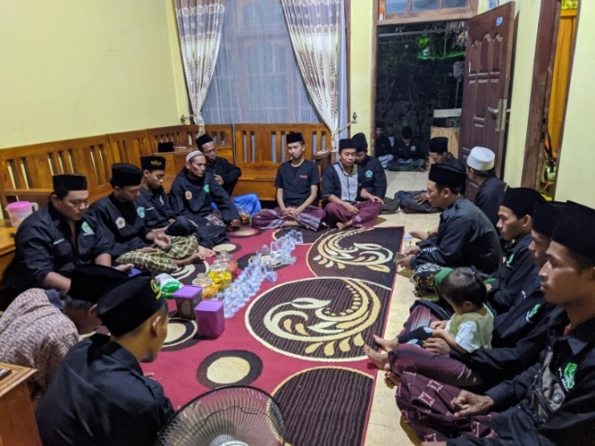Figure 1 Inculturation with Pagar Nusa*

*Source: Researcher document*

1. **Discovery**

At this stage, members of Pencak Silat NU Pagar Nusa are motivated to explore assets that they are not aware of. This discovery process involves interviewing respondents to collect primary data. These meetings are usually held at pencak silat training grounds, mosque foyers and in the homes of elder teachers, where inspirational stories about past achievements and skills possessed by members are shared. In addition, members are also invited to map their assets by relating the successes they have achieved and the skills they have mastered, for example, some of them have been involved in farming and are still continuing to this day.

The first group discussion activity was held on Wednesday night, February 8, 2023, at the house of Mr. Zahidin as an elder of Pagar Nusa Lembor. This discussion was carried out by 9 people, namely Kang Zahidin, Kang Halim, Kang Shohibul, Kang Rosyid, Kang Jefri, Kang Fahim, Kang Fendy, Kang Faiq and Researchers. This discussion discussed various matters related to Pagar Nusa Lembor, and the results showed that members of Pencak Silat NU Pagar Nusa have assets in the form of human resources that develop over time, a strong spirit of mutual cooperation, and natural assets in the form of agricultural land that has not been fully utilized. In addition, members also talked about their hopes to use the land productively in the future. This discussion took place in a relaxed and informal atmosphere.

*Figure 2 FGD with Pagar Nusa*

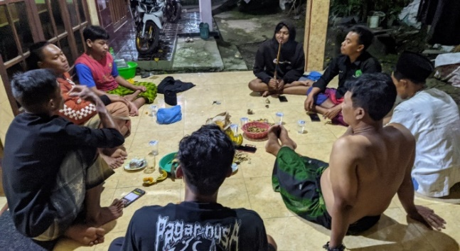

*Source: Researcher document*

1. **Dream**

Members of Pencak Silat Nahdlatul Ulama' Pagar Nusa Lembor were then asked to determine priorities in the development of these dreams. After joint deliberation, several wishes have been realized, which are interconnected and related, forming a list of dreams to be achieved, ranging from transformation to a new economy. After the meeting, it was agreed to handle the nearest natural asset, namely the vacant land provided by the Branch Leader of Nahdlatul Ulama' Lembor. From the joint discussion, some of the realized desires are related to each other, which can be seen in the following table:

*Table 1. Results of the Nusa Lembor Fence Dream*

|  |  |
| --- | --- |
| **No.** | **Result Dream** |
| 1 | Pencak Silat Nahdlatul Ulama' Pagar Nusa Lembor can take advantage of its potential |
| 2 | Members of Pencak Silat NU Pagar Nusa Lembor can use their skills |
| 3 | Pagar Nusa Lembor has a new movement transformation |
| 4 | Pagar Nusa Lembor can manage the land owned to be useful |
| 5 | Pagar Nusa Lembor can create a new economy |
| 6 | Pagar Nusa has a strong family synergy |

*Source: FGD with Members of Pagar Nusa Lembor*

1. **Design**

At this stage, the members of Pencak Silat Nahdlatul Ulama' Pagar Nusa Desa Lembor who were involved before, designed a participatory action process strategy by considering the assets they have, as well as constructing and collaborating on the Dreams/Hopes/Goals that have been set by them. The decision of the program strategy is to change to something better according to what is expected. There are several strategies to make dreams come true, namely:

*Table 2. Strategies to make dreams come true*

|  |  |  |
| --- | --- | --- |
| **Assets** | **Dream** | **Strategy** |
| Vacant land assets owned by Pagar Nusa | There is productivity on the vacant land of Pagar Nusa Lembor. | Making FGD Learn together how to manage vacant land with banana plants. |
| There is the cultivation of vacant land through the planting of banana trees. | Carrying out the process of cultivating vacant land by planting banana trees. |
| The Existence of NU Pagar Nusa Lembor Pencak Silat | There is a transformation of new activities from the members of Pagar Nusa Lembor in terms of thought, awareness and creativity. As well as to protect the environment. | Utilizing the assets owned by the organization as a da'wah medium and transformation process. |

*Source: FGD with Pagar Nusa Lembor*

1. **Define**

The action steps that have been agreed upon by Pagar Nusa Lembor in the transformation of vacant land are as follows:

1. **Forming the Program Structure**

The formation of the program structure and determining the action is determined by FGD together with members of pencak silat Nahdlatul Ulama Pagar Nusa Lembor, this is done so that there are no misunderstandings in communication. The determination of the program by considering the busyness of each community, it is necessary to review when this activity transformation program will run in order to provide benefits for the NU Pagar Nusa Pencak Silat organization in Lembor Village. The structure of this Transformation Program is coordinated by Kang Shohibul and Kang Mufa assisted by the members of pencak silat Pagar Nusa Lembor who are included in the business development division, namely Kang Yamin, Kang Sabihis, Kang Bahrul, Kang Edi, and there are some conditional members who are not included in the board of directors who participate.

1. **Socialization and FGD together**

The FGD was carried out by researchers and members of pencak silat Nahdlatul Ulama Pagar Nusa Lembor on Thursday night, Friday, March 16, 2023 at the Porch of the Jami'At-Taqwa Lembor Mosque. The FGD was attended by 13 members, namely Kang Rosyid (Chairman of Pagar Nusa Lembor), Kang Fendy, Kang Mufa, Kang Shohibul, Kang Jefri, Kang Agus, Kang Faiq, Kang Safir, Kang Fahim, Kang Fakhrul, Kang Yamin, Kang Sabihis, Kang Edi and researchers. The process was carried out for approximately 3 hours. The first thing that was carried out was socialization from the Head of the Pagar Nusa Branch in Lembor village conveying the purpose of transforming activities for Pagar Nusa Lembor members to cultivate vacant land that has not been productive by planting banana trees. There were many opinions from members, one of which was from Kang Shohibul who received a lot of approval, he said:

*"Staying in the sign of any glove, it's easier to get around, and you don't know a lot of people"*

The results of this FGD were then given to the NU Branch Leaders and Villages to get blessings and permits. After that, the process of discussing together continued how the steps taken in carrying out vacant land cultivation by planting banana trees until finding mutually agreed designs.

*Figure 3 Socialization and FGD with Pagar Nusa*

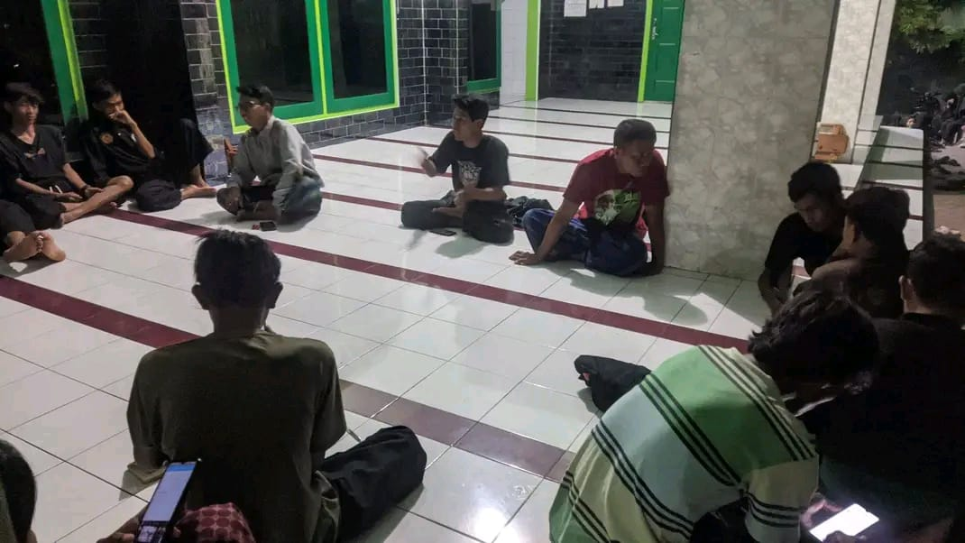

*Source: Researcher Documentation*

1. **Collection of Materials and Tools**

The process of collecting materials and tools is commanded by Shohibul as the Coordinator. The following are the tools and materials prepared by Pencak Silat NU Pagar Nusa Lembor:

1. **Determining the Location of Vacant Land**

The first is to determine the location of the vacant land to be used, in this study in accordance with the joint discussion that the land agreement used is an empty land measuring 554 M2 belonging to Pencak Silat Nahdlatul Ulama Pagar Nusa Lembor which has not been used and has not been productive. The vacant land of Pagar Nusa Lembor is an empty land asset whose ownership status is in the Branch Leader of Nahdlatul Ulama Lembor. This land is said to be the land of Pencak Silat Nahdlatul Ulama Pagar Nusa Lembor because it has been handed over the right to process it to Pencak Silat NU Pagar Nusa Lembor to support the improvement of the organization as an autonomous body of NU.

*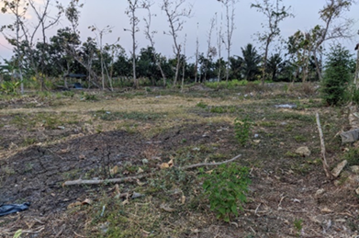Figure 4 Vacant land of Pagar Nusa*

*Source: Researcher Document*

1. **Determining Banana Seeds**

The next thing to be prepared after knowing the condition of the vacant land is banana tree seedlings, these banana tree seedlings will be used and managed as a medium for the use of vacant land. The banana tree seedlings selected are banana tree seedlings of the Bulu Raja Banana type. The seeds were obtained from purchases made by Kang Mufa as the Deputy Coordinator. The money used for the purchase of the seeds came from Kang Halimuddin as the coach of Pagar Nusa which was given to Kang Mufa, at the time of giving the money he said:

*"This is a lot of fun for ducks to buy grape seeds".*

In the quote, the researcher assessed that the Rp. 400,000 can be detailed as follows:

*Table 3. Purchase of banana tree seedlings*

|  |  |  |  |
| --- | --- | --- | --- |
| **Purchase of Banana Tree Seedlings in Pagar Nusa Lembor** | | | |
| **Types of Seeds** | **Unit Price** | **Number of Seeds** | **Total** |
| Feather Plantain | Rp. 4.000 | 100 Seeds | Rp. 400.000, |
| **Total** | | | **Rp. 400.000,** |

*Source: Researcher Data*

1. **Carrying out the process of cultivating vacant land**
2. **Land Clearing**

The first step in the processing of vacant land by Pencak Silat Nahdlatul Ulama Pagar Nusa Lembor Village is to clean the land through mutual cooperation. On Friday morning, seven members, led by Kang Shohibul, gathered in the MI courtyard before heading to the land to be cleared. They use simple tools such as sickles and hoes to clear grass and small trees, which are then burned. With great enthusiasm, they worked together to sterilize 544 m² of land, which was previously unutilized, for the transformation of activities according to the planned program.

*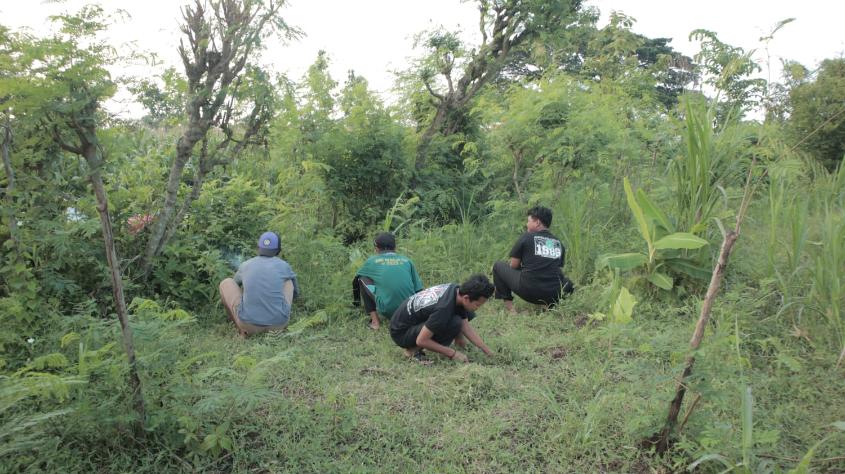Figure 5 Clearing of Vacant Land in Pagar Nusa*

*Source: Researcher Document*

1. **Banana Tree Planting**

Pencak silat Nahdlatul Ulama Pagar Nusa Lembor planted banana tree seedlings on Friday morning, one week after the land clearing, involving seven members led by Coordinator Kang Shohibul. Using a hoe and sickle, they dug a hole 20 cm deep, planted banana seedlings with the top protruding 10-12 cm, and kept the planting distance between the trees about 2 m for the length of the land and 3 m for the width of the land, in an area of 16 x 34 m or 554 m2. Of the 100 seedlings purchased, 75 were successfully planted in this process, which will continue to be carried out by Pagar Nusa members until the entire land is planted with bananas.

*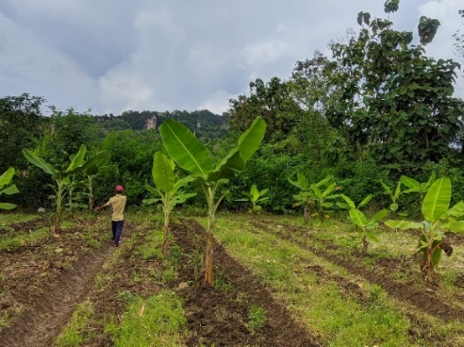Figure 6 Banana Tree Planting*

*Source: Researcher Document*

1. **Therapy**

The banana tree care stage begins a week after planting seedlings and is carried out conditionally every week to once a month, precisely every Friday morning by Kang Shohibul and members of Pencak Silat Nahdlatul Ulama Pagar Nusa Lembor. Treatments are carried out in a structured and alternating manner, including loosening the soil or making cans to help the development of roots and humps, pest prevention by cleaning the grass around the tree, and pruning dry leaves so as not to interfere with tree growth.

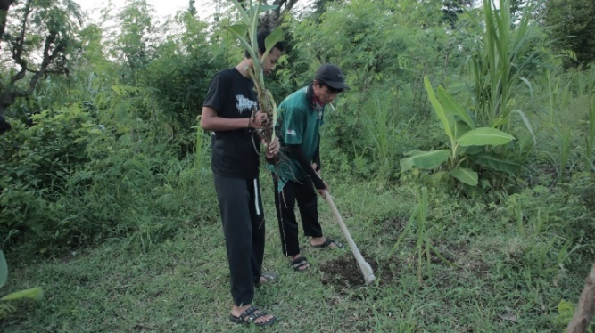*Figure 7 Banana Tree Care*

*Source: Researcher Document*

1. **Harvesting and Sales**

The last stage of the transformation of vacant land use by Pencak Silat Nahdlatul Ulama Pagar Nusa Lembor is the harvest period, which is the result of the banana tree planting process for approximately 8 months. The first harvest was carried out in October 2023 by me, Kang Ashari, and Kang Shohibul as coordinators. The harvested bananas were sold directly by Kang Shohibul to Pak Sholik, a banana middleman from Lembor Village, who came directly to the land location, can be seen in the following table:

*Table 4. Harvest and Sales*

|  |  |  |  |
| --- | --- | --- | --- |
| **Harvest of Banana Pagar Nusa Lembor** | | | |
| **Harvest Period** | **Bunches** | **Price Per Bunch** | **Sum** |
| First (October 2023) | 14 Bunches | 25.000 | 350.000, |
| **Sum** | | | **350.000,** |

*Source: Researcher Data*

The da'wah transformation carried out by Pencak Silat Nahdlatul Ulama (NU) Pagar Nusa Lembor has resulted in significant changes in various aspects. In terms of thinking, the members of this organization became aware of the assets and potentials they had, changing the focus of da'wah from just self-defense to a wider range, including the use of vacant land. This awareness also attracts the interest of the community and other NU members to participate in land use. In terms of behavior, they learned how to use vacant land by planting banana trees, from clearing the land to selling crops. From an economic perspective, they are able to create organizational economic independence through the use of vacant land. Religiously, this activity also teaches the importance of protecting the environment according to Islamic teachings.

Monitoring and evaluation are carried out to ensure that these activities are running as planned and to identify and correct errors. This process involves data collection, analysis, planning, and implementation of programs, as well as assessment of the impacts and benefits produced. This activity was held in October 2023 and shows that the transformation of da'wah through the use of vacant land brings positive changes to the community, especially in increasing awareness of the assets and potentials owned, as well as the importance of protecting the environment.

The social change resulting from this program is oriented towards community empowerment, which includes awareness of assets and potential, as well as mobilization to create independence and prosperity [20]. The approach used is Asset Based Community Development (ABCD), which emphasizes the development of potential that exists in the organization and society. Although it still needs continuous improvement and evaluation, this program has led the community towards significant social improvement and is expected to continue to grow in the future [21].

**Conclusion**

Research on da'wah bil kha conducted by Pencak Silat Nahdlatul Ulama Pagar Nusa in Lembor Village, Brondong District, Lamongan Regency, shows that the transformation process is carried out with an Asset Based Community Development (ABCD) approach. The strategies used include socialization on the use of vacant land, the formation of program structures, Focus Group Discussions (FGD), and joint learning about land transformation. The process of using vacant land starts from cleaning, planting banana trees, maintenance, to harvesting and sales. This transformation shows a significant change in the thinking of Pagar Nusa members, who initially only focused on martial da'wah, into an organization that is able to preach in a social and environmental context.

The implementation of bil hal da'wah by Pencak Silat NU Pagar Nusa showed positive results. Members of Pencak Silat and the surrounding community have become more aware of their assets and potential, as well as know how to use vacant land effectively. This activity also attracted the interest of the community, including NU students and NU Branch Leaders, who also participated in the use of vacant land. From an economic perspective, this activity produces economic independence for organizations that previously had no income. In addition, from a religious perspective, Pencak Silat NU Pagar Nusa succeeded in conveying the importance of protecting the environment as part of Islamic teachings, thus strengthening da'wah in maintaining social and environmental balance.

**References**

Afandi, Agus. *Metodologi Pengabdian Masyarakat*. Jakarta: Kementrian Agama RI, 2022.

Ahmad Syarbaini. “Konsep Ihya’ Al-Mawat Menurut Hukum Ekonomi Syariah (Dalam Fiqh Islam) Ditinjau Dari Undang-Undang Pokok Agraria Dan Undang-Undang Kehutanan.” *Hei Ema : Jurnal Riset Hukum, Ekonomi Islam, Ekonomi, Manajemen dan Akuntansi* 1, no. 2 (July 27, 2022): 45–61. http://jurnal.stisalhilalsigli.ac.id/index.php/jhei/article/view/72.

Al-Kautsari, Mirza Maulana. “Asset-Based Community Development : Strategi Pengembangan Masyarakat.” *Empower: Jurnal Pengembangan Masyarakat Islam* 4, no. 2 (December 30, 2019): 259. https://syekhnurjati.ac.id/jurnal/index.php/empower/article/view/4572.

Dagun, Deni Irawan, and A.raflik. “Pencak Silat Sebagai Media Dakwah (Analisis Pada Perguruan Pencak Silat Susun Sirih Kecamatan Selakau).” *Jurnal Kajian Dakwah dan Sosial Keagamaan* 6, no. 1 (2021): 24–43.

Desa, Dokumen. *Data Statistik Pnduduk Desa Lembor Tahun 2023*. Lamongan, 2023.

Hardian, Novri. “Dakwah Dalam Perspektif Al-Qur’an Dan Hadits.” *Al-Hikmah: Jurnal Dakwah dan Ilmu Komunikasi* (June 1, 2018): 42–52. https://ejournal.uinib.ac.id/jurnal/index.php/alhikmah/article/view/92.

Mahri, Rizal. “Dakwah Kampus Berbasis Riset.” *Dakwah* xiv, no. 1 (2013): 51.

Muttaqin, Zaenal, Deasy Silvya Sari, and Ratih Purbasari. “Pemanfaatan Lahan Kosong: Mengupayakan Ketahanan Pangan Global Dalam Keseharian Masyarakat Lokal Di Rw 12, Desa Sayang, Jatinangor, Sumedang.” *Prosiding Penelitian dan Pengabdian kepada Masyarakat* 5, no. 3 (January 30, 2019): 237. http://jurnal.unpad.ac.id/prosiding/article/view/20062.

Rahayu, Betty, Herry Setyawan, and Mansur. *Asset Based Community Development (ABCD)*. Samarinda: PT Gaptek Media Pustaka, 2022.

Reskiyono, Joko. “Pagar Nusa Sebagai Media Dakwah Di Desa Jurug Kecamatan Sooko Kabupaten Ponorogo.” IAIN Ponorogo, 2022.

Syaikh Muhammad bin Qosim Al Ghozi Al Musamma. *Syarah Fathul Qorib Al Mujib*. 3rd ed. Kediri: Lirboyo Press, 2017.

Tuhumury, Petronella. *Transformasi Sebuah Paradigma Terobosan*. Sekolah Tinggi Theologia Jaffray, 2018.

Undriyati, Siti. “Strategi Dakwah Bil Hal Di Masjid Jami’ Asholikhin Bringin Ngaliyan.” *Skripsi* (2015).

Yasril, Yazid, and Alhidayatillah Nur. “Partisipasi Masyarakat Dalam Pemberdayaan Lingkungan.” *Jurnal Dakwah Risalah* 28, no. 1 (August 2, 2018): 1. http://ejournal.uin-suska.ac.id/index.php/risalah/article/view/5538.

Yefni, Yefni. “Analisis Model Pemberdayaan Masyarakat.” *Masyarakat Madani: Jurnal Kajian Islam dan Pengembangan Masyarakat* 3, no. 2 (December 1, 2018): 42. https://ejournal.uin-suska.ac.id/index.php/jmm/article/view/6362.

Zayadi, Ahmad. “Ramadan Dan Dakwah Transformatif.” *Kementrian Agama RI*. Last modified 2023. https://kemenag.go.id/opini/ramadan-dan-dakwah-transformatif-0iSyE.

1. Rizal Mahri, “Dakwah Kampus Berbasis Riset,” *Dakwah* xiv, no. 1 (2013): 51.
2. (Syarbaini, 2022)
3. (Al Musamma, 2017)
4. (Al Musamma, 2017)
5. Ahmad Zayadi, “Ramadan Dan Dakwah Transformatif,” *Kementrian Agama RI*, last modified 2023, https://kemenag.go.id/opini/ramadan-dan-dakwah-transformatif-0iSyE.
6. (Al Musamma, 2017)
7. Dagun, Deni Irawan, and A.raflik, “Pencak Silat Sebagai Media Dakwah (Analisis Pada Perguruan Pencak Silat Susun Sirih Kecamatan Selakau),” *Jurnal Kajian Dakwah dan Sosial Keagamaan* 6, no. 1 (2021): 24–43.
8. Dokumen Desa, *Data Statistik Pnduduk Desa Lembor Tahun 2023* (Lamongan, 2023).
9. Joko Reskiyono, “Pagar Nusa Sebagai Media Dakwah Di Desa Jurug Kecamatan Sooko Kabupaten Ponorogo” (IAIN Ponorogo, 2022).
10. Zaenal Muttaqin, Deasy Silvya Sari, and Ratih Purbasari, “Pemanfaatan Lahan Kosong: Mengupayakan Ketahanan Pangan Global Dalam Keseharian Masyarakat Lokal Di Rw 12, Desa Sayang, Jatinangor, Sumedang,” *Prosiding Penelitian dan Pengabdian kepada Masyarakat* 5, no. 3 (January 30, 2019): 237, http://jurnal.unpad.ac.id/prosiding/article/view/20062.
11. Dagun, Irawan, and A.raflik, “Pencak Silat Sebagai Media Dakwah (Analisis Pada Perguruan Pencak Silat Susun Sirih Kecamatan Selakau).”
12. Siti Undriyati, “Strategi Dakwah Bil Hal Di Masjid Jami’ Asholikhin Bringin Ngaliyan,” *Skripsi* (2015).
13. Novri Hardian, “Dakwah Dalam Perspektif Al-Qur’an Dan Hadits,” *Al-Hikmah: Jurnal Dakwah dan Ilmu Komunikasi* (June 1, 2018): 42–52, https://ejournal.uinib.ac.id/jurnal/index.php/alhikmah/article/view/92.
14. (Syarbaini, 2022)
15. (Al Musamma, 2017)
16. Petronella Tuhumury, *Transformasi Sebuah Paradigma Terobosan* (Sekolah Tinggi Theologia Jaffray, 2018).
17. Mirza Maulana Al-Kautsari, “Asset-Based Community Development : Strategi Pengembangan Masyarakat,” *Empower: Jurnal Pengembangan Masyarakat Islam* 4, no. 2 (December 30, 2019): 259, https://syekhnurjati.ac.id/jurnal/index.php/empower/article/view/4572.
18. Agus Afandi, *Metodologi Pengabdian Masyarakat* (Jakarta: Kementrian Agama RI, 2022).
19. Betty Rahayu, Herry Setyawan, and Mansur, *Asset Based Community Development (ABCD)* (Samarinda: PT Gaptek Media Pustaka, 2022).
20. Yazid Yasril and Alhidayatillah Nur, “Partisipasi Masyarakat Dalam Pemberdayaan Lingkungan,” *Jurnal Dakwah Risalah* 28, no. 1 (August 2, 2018): 1, http://ejournal.uin-suska.ac.id/index.php/risalah/article/view/5538.
21. Yefni Yefni, “Analisis Model Pemberdayaan Masyarakat,” *Masyarakat Madani: Jurnal Kajian Islam dan Pengembangan Masyarakat* 3, no. 2 (December 1, 2018): 42, https://ejournal.uin-suska.ac.id/index.php/jmm/article/view/6362.